Welcome to
Trinity Lutheran Church
Lutheran Church—Missouri Synod
A Stephen Ministry Congregation

1354 South Otsego Avenue
Gaylord, Michigan 49735
Church Phone: (989) 732-4816

Church Email: secretary@trinitygaylord.com
www.trinitygaylord.com

Office Hours: Monday through Friday 9am – 1pm

OUR PURPOSE
…is to LOVE GOD, LOVE OTHERS, AND SERVE THE WORLD by worshiping the Lord Jesus, bringing our members into Christ-like maturity, and equipping them through Word and Sacrament for their mission and ministry. We go heart to heart into the world with Jesus, sharing His love, caring for one another, praying, and bringing the lost into a relationship with Christ, by the working of the Holy Spirit.

April 10, 2022
Palm Sunday
Preacher: Rev. Ken Bernthal

ABOUT OUR WORSHIP
We welcome all who gather here today! We are blessed to celebrate together the mercy, grace, and love we have from God through the death and resurrection of our Lord Jesus Christ.

Children: Families with children are very welcome here. Having children in church is important so they can begin to learn about their faith in Jesus, and it’s good for the whole congregation to see. Please feel comfortable keeping “squirmy” kids in the service. This is where they belong, too!

Pew Cards: Guests and Members, please fill out the Guest/Member card located on the back of the pew in front of you and pass it to the end of the aisle. If you forget you can put it in the offering plate on your way out.

If standing is difficult: Please feel free to remain seated during any portion of the service. Please let an Elder or Usher know if you need communion in your pew seat.

About our celebration of Holy Communion: We celebrate the Lord’s Supper in the confession and glad confidence that, as he says, our Lord gives into our mouths not only bread and wine but his very body and blood to eat and to drink for the forgiveness of sins and to strengthen our union with him and with one another. Our Lord invites to his table those who trust his words, repent of all sin, and set aside any refusal to forgive and love as he forgives and loves us, that they may show forth his death until he comes.

Because those who eat and drink our Lord’s body and blood contrary to that which is stated above do so to their great harm, and also because Holy Communion is a confession of the faith which is confessed at this altar. Anyone who is not yet instructed, in doubt, or who hold a confession differing from that of the Lutheran Church—Missouri Synod, and yet desire to receive the sacrament, are asked first to speak with Pastor. Those not communing are still invited to come forward for a blessing from Pastor, and you may indicate this by crossing your arms over your chest.
TTTTTT

GREETING

P Peace be with you.
C And also with you.
T ORDER OF SERVICE T
(The liturgy is from Divine Service Setting four LSB pg. 203ff)

OPENING HYMN
All Glory, Laud, and Honor LSB 442
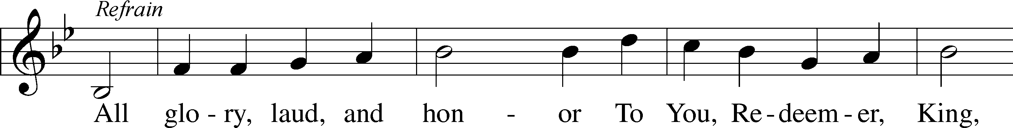
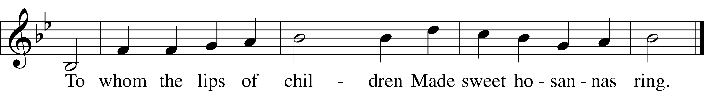
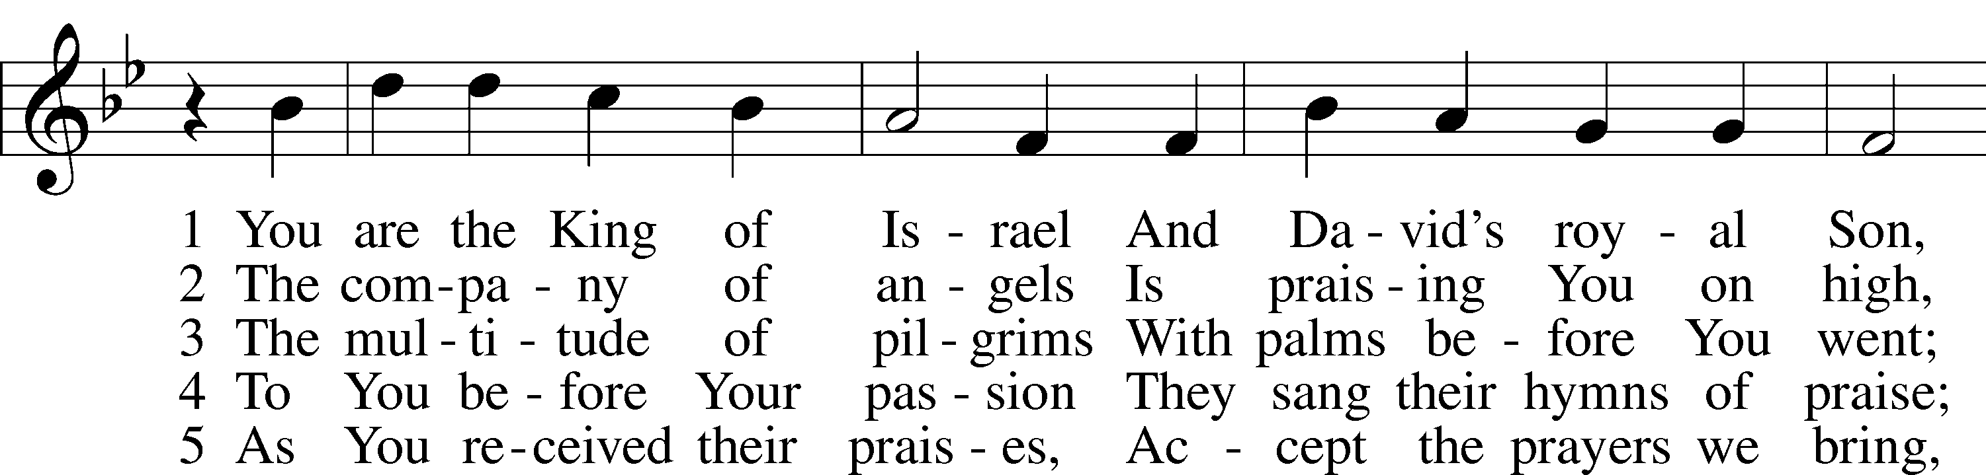
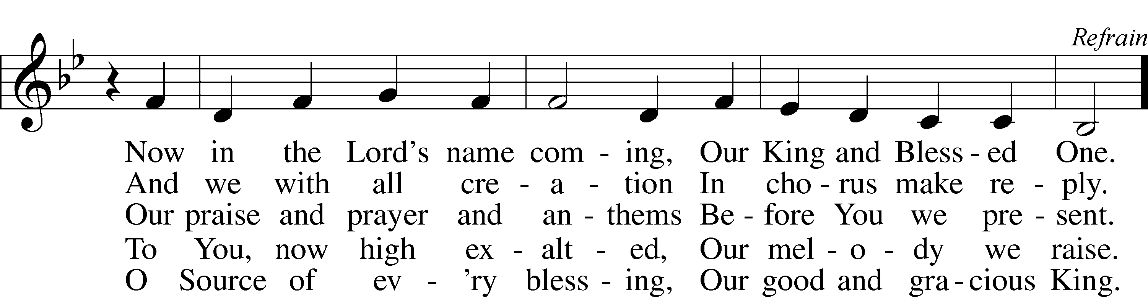
Text: Theodulf of Orléans, c. 762–821; tr. John Mason Neale, 1818–66, alt.
Tune: Melchior Teschner, 1584–1635, alt.
Text and tune: Public domain

Please stand as able
CONFESSION and ABSOLUTION
The sign of the cross may be made by all in remembrance of their Baptism.

P In the name of the Father and of the T Son and of the Holy Spirit.
C Amen.
P Our help is in the name of the Lord,
C who made heaven and earth.
P If You, O Lord, kept a record of sins, O Lord, who could stand?
C But with You there is forgiveness; therefore, You are feared.
P Since we are gathered to hear God’s Word, call upon Him in prayer and praise, and receive the body and blood of our Lord Jesus Christ in the fellowship of this altar, let us first consider our unworthiness and confess before God and one another that we have sinned in thought, word, and deed, and that we cannot free ourselves from our sinful condition. Together as His people let us take refuge in the infinite mercy of God, our heavenly Father, seeking His grace for the sake of Christ, and saying: God, be merciful to me, a sinner.
C Almighty God, have mercy upon us, forgive us our sins, and lead us to everlasting life. Amen.
P Almighty God, merciful Father, in Holy Baptism You declared us to be Your children and gathered us into Your one, holy Church, in which You daily and richly forgive us our sins and grant us new life through Your Spirit. Be in our midst, enliven our faith, and graciously receive our prayer and praise; through Your Son, Jesus Christ, our Lord.
C Amen.

SERVICE OF THE WORD
INTROIT Psalm 24:7–10; antiphon: Psalm 118:26
P Blessèd is he who comes in the name of the Lord!
We bless you from the house of the Lord.
C Lift up your heads, O gates! And be lifted up, O ancient doors,
that the King of glory may come in.
P Who is this King of glory?
C The Lord, strong and mighty, the Lord, mighty in battle!
P Lift up your heads, O gates! And lift them up, O ancient doors,
that the King of glory may come in.
C Who is this King of glory?
The Lord of hosts, he is the King of glory!
P Blessèd is he who comes in the name of the Lord!
We bless you from the house of the Lord.
KYRIE LSB 204
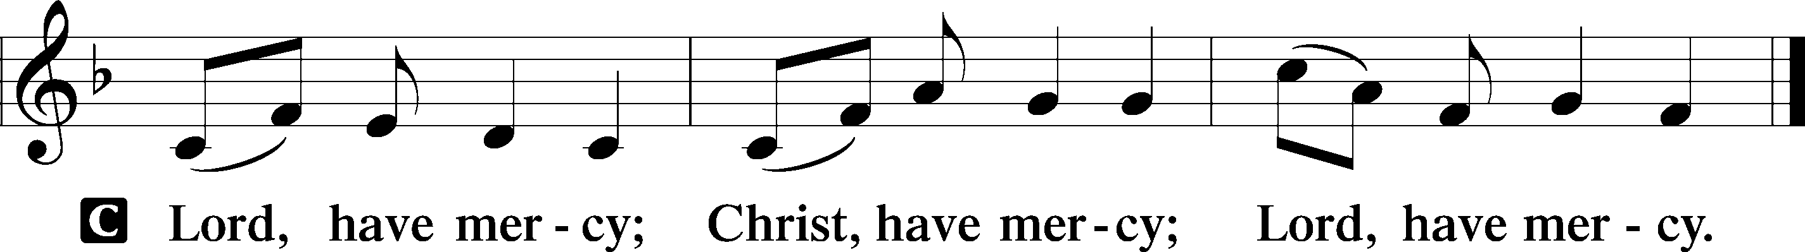

SALUTATION AND COLLECT OF THE DAY
P The Lord be with you.
C And also with you.

P Let us pray.
Almighty God, grant that we who have celebrated the Lord’s resurrection may by Your grace confess in our life and conversation that Jesus is Lord and God; through the same Jesus Christ, Your Son, who lives and reigns with You and the Holy Spirit, one God, now and forever.
C Amen.

Please be seated

OLD TESTAMENT READING Deuteronomy 32:36–39
³⁶ The Lord will vindicate his people
and have compassion on his servants,
when he sees that their power is gone
and there is none remaining, bond or free.
³⁷Then he will say, “Where are their gods,
the rock in which they took refuge,
³⁸who ate the fat of their sacrifices
and drank the wine of their drink offering?
Let them rise up and help you;
let them be your protection!
³⁹“See now that I, even I, am he,
and there is no god beside me;
I kill and I make alive;
I wound and I heal;
and there is none that can deliver out of my hand.”
P This is the Word of the Lord.
C Thanks be to God.

EPISTLE Philippians 2:5–11
⁵Have this mind among yourselves, which is yours in Christ Jesus, ⁶who, though he was in the form of God, did not count equality with God a thing to be grasped, ⁷but made himself nothing, taking the form of a servant, being born in the likeness of men. ⁸And being found in human form, he humbled himself by becoming obedient to the point of death, even death on a cross. ⁹Therefore God has highly exalted him and bestowed on him the name that is above every name, ¹⁰so that at the name of Jesus every knee should bow, in heaven and on earth and under the earth, ¹¹and every tongue confess that Jesus Christ is Lord, to the glory of God the Father.

P This is the Word of the Lord.
C Thanks be to God.

CHOIR ANTHEM “On a borrowed colt He rode”
Please stand as able

HOLY GOSPEL Luke 19:28–40
P The Holy Gospel according to St. Luke, the nineteenth chapter.
C Glory to You, O Lord.

²⁸When [Jesus] had said these things, he went on ahead, going up to Jerusalem. ²⁹When he drew near to Bethphage and Bethany, at the mount that is called Olivet, he sent two of the disciples, ³⁰saying, “Go into the village in front of you, where on entering you will find a colt tied, on which no one has ever yet sat. Untie it and bring it here. ³¹If anyone asks you, ‘Why are you untying it?’ you shall say this: ‘The Lord has need of it.’” ³²So those who were sent went away and found it just as he had told them. ³³And as they were untying the colt, its owners said to them, “Why are you untying the colt?” ³⁴And they said, “The Lord has need of it.” ³⁵And they brought it to Jesus, and throwing their cloaks on the colt, they set Jesus on it. ³⁶And as he rode along, they spread their cloaks on the road. ³⁷As he was drawing near—already on the way down the Mount of Olives—the whole multitude of his disciples began to rejoice and praise God with a loud voice for all the mighty works that they had seen, ³⁸saying, “Blessed is the King who comes in the name of the Lord! Peace in heaven and glory in the highest!” ³⁹And some of the Pharisees in the crowd said to him, “Teacher, rebuke your disciples.” ⁴⁰He answered, “I tell you, if these were silent, the very stones would cry out.”

P This is the Gospel of the Lord.
C Praise to You, O Christ.

NICENE CREED
C I believe in one God,
the Father Almighty,
maker of heaven and earth
and of all things visible and invisible.
And in one Lord Jesus Christ,
the only-begotten Son of God,
begotten of His Father before all worlds,
God of God, Light of Light,
very God of very God,
begotten, not made,
being of one substance with the Father,
by whom all things were made;
who for us men and for our salvation came down from heaven
and was incarnate by the Holy Spirit of the virgin Mary
and was made man;
and was crucified also for us under Pontius Pilate.
He suffered and was buried.
And the third day He rose again according to the Scriptures
and ascended into heaven
and sits at the right hand of the Father.
And He will come again with glory to judge both the living and the dead,
whose kingdom will have no end.
And I believe in the Holy Spirit,
the Lord and giver of life,
who proceeds from the Father and the Son,
who with the Father and the Son together is worshiped and glorified,
who spoke by the prophets.
And I believe in one holy Christian and apostolic Church,
I acknowledge one Baptism for the remission of sins,
and I look for the resurrection of the dead
and the life T of the world to come. Amen.

Please be seated

“ALL GOD’S CHILDREN” TALK

SERMON HYMN
Hosanna, Loud Hosanna LSB 443
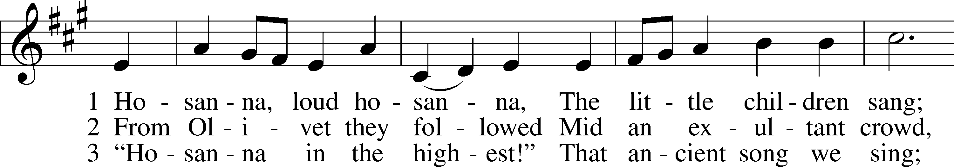
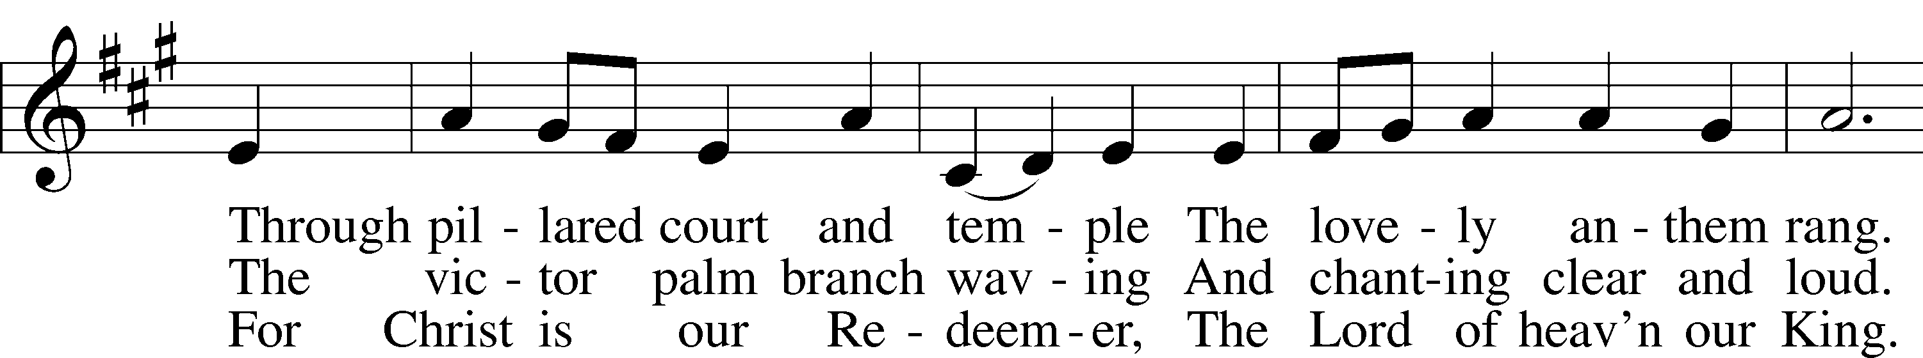
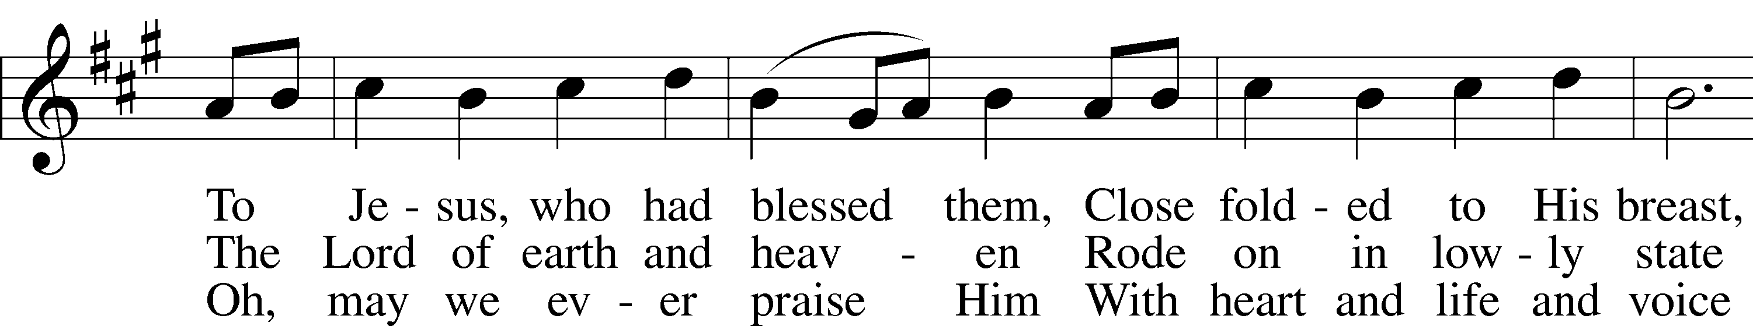
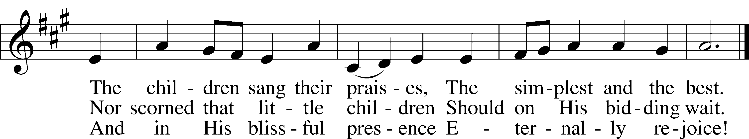
Text: Jeannette Threlfall, 1821–80, alt.
Tune: Gesangbuch der Herzogl. Hofkapelle, 1784, Württemberg
Text and tune: Public domain

SERMON
Please stand as able

PRAYER of the CHURCH
After each Segment:
P Lord, in Your Mercy,
C Hear our Prayer.
After Final Segment:
P Hear us as we pray in His name and as He has taught us:
LORD’S PRAYER
C Our Father who art in heaven,
hallowed be Thy name,
Thy kingdom come,
Thy will be done on earth
as it is in heaven;
give us this day our daily bread;
and forgive us our trespasses
as we forgive those
who trespass against us;
and lead us not into temptation,
but deliver us from evil.
For Thine is the kingdom
and the power and the glory
forever and ever. Amen.

SERVICE of the SACRAMENT

PREFACE LSB 208
P The Lord be with you.
C And also with you.

P Lift up your hearts.
C We lift them to the Lord.

P Let us give thanks to the Lord our God.
C It is right to give Him thanks and praise.

P It is truly good, right, and salutary that we should at all times and in all places give thanks to You, O Lord, holy Father, almighty and everlasting God, for the countless blessings You
so freely bestow on us and all creation. Above all, we give thanks for Your boundless love shown to us when You sent Your only-begotten Son, Jesus Christ, into our flesh and laid on Him our sin, giving Him into death that we might not die eternally. Because He is now risen from the dead and lives and reigns to all eternity, all who believe in Him will overcome sin and death and will rise again to new life. Therefore with angels and archangels and with all the company of heaven we laud and magnify Your glorious name, evermore praising You and singing;

SANCTUS LSB 208
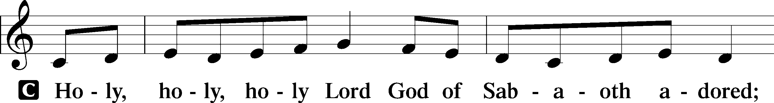
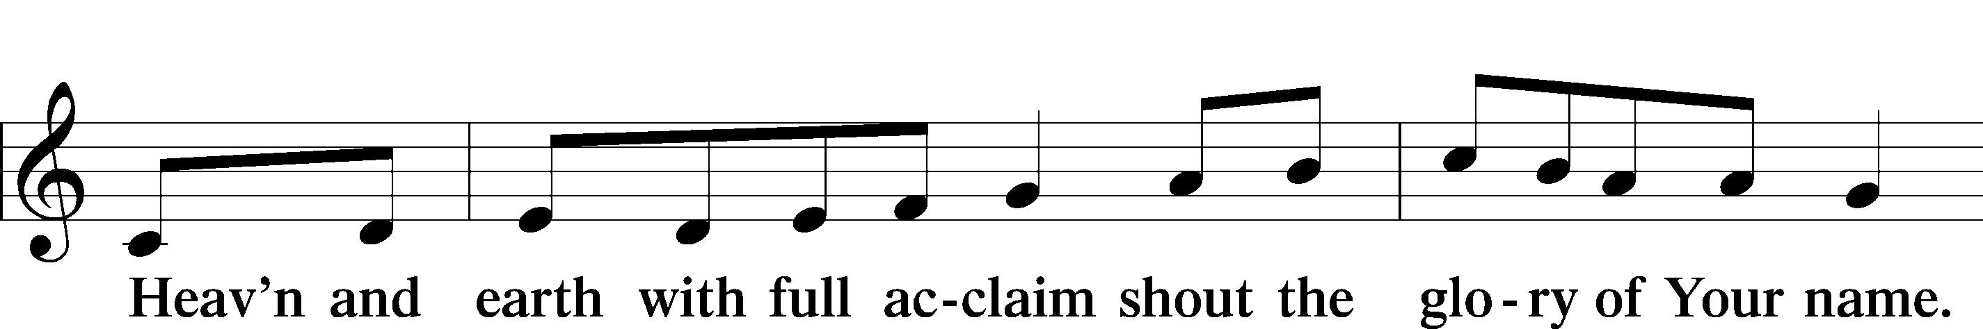
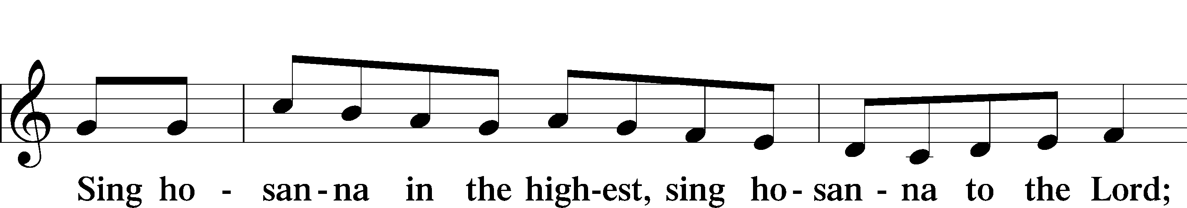

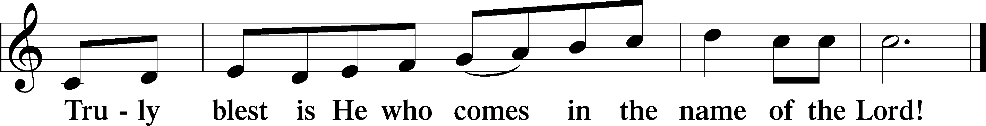

THE WORDS OF OUR LORD
P Our Lord Jesus Christ, on the night when He was betrayed, took bread, and when He had given thanks, He broke it and gave it to the disciples and said: “Take, eat; this is My T body, which is given for you. This do in remembrance of Me.”
In the same way also, He took the cup after supper, and when He had given thanks, He gave it to them, saying: “Drink of it, all of you; this cup is the New Testament in My T blood, which is shed for you for the forgiveness of sins. This do, as often as you drink it, in remembrance of Me.”

PAX DOMINI
P The peace of the Lord be with you always.
C Amen.
AGNUS DEA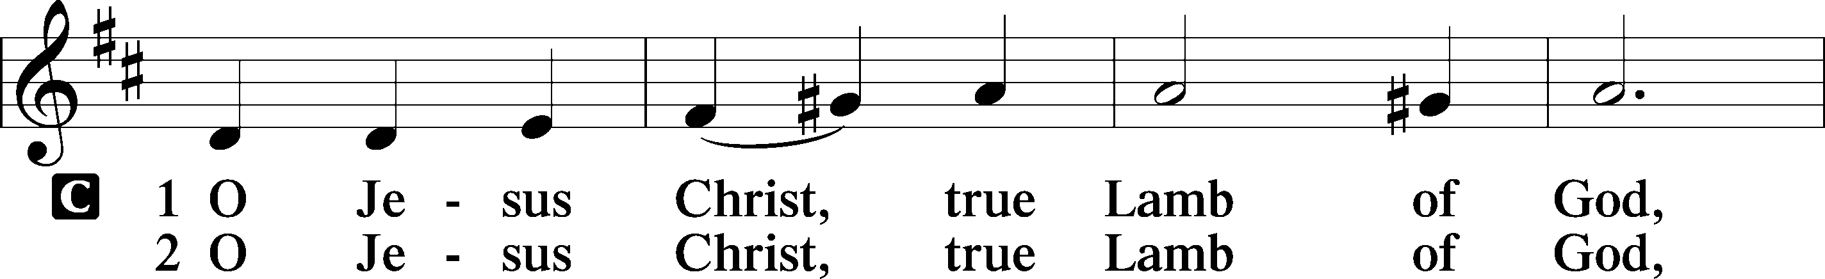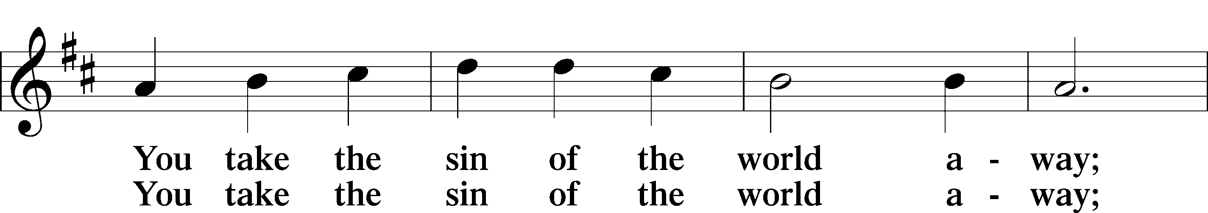
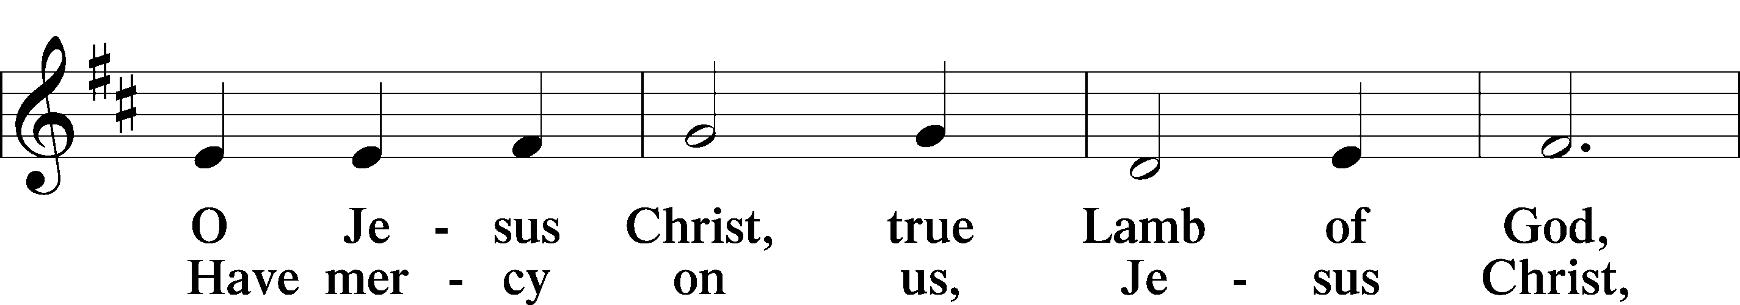
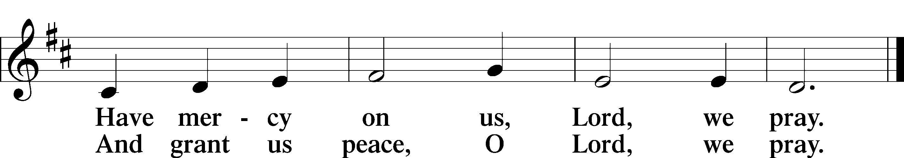

Please be seated

DISTRIBUTION
The pastor and those who assist him receive the body and blood of Christ first, then Communion will be served in a continuous fashion. Households may commune at the same time together. Ushers will help direct you forward via the center aisle; please return to your seats via the side aisles. Gluten-free bread is available for those who need it, as is non-alcoholic grape juice. Simply request either when you come forward to receive Communion.

DISTRIBUTION HYMN
Lord Jesus Christ, You Have Prepared LSB 622
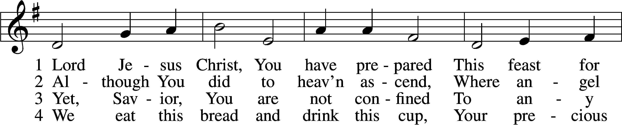
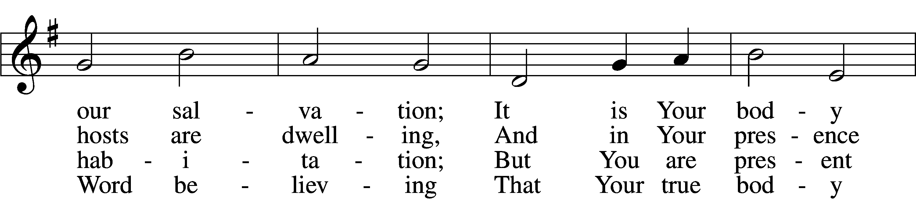
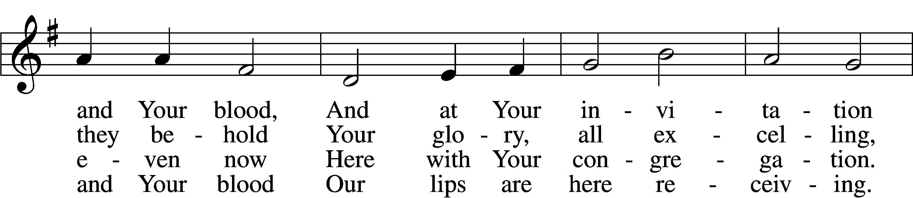
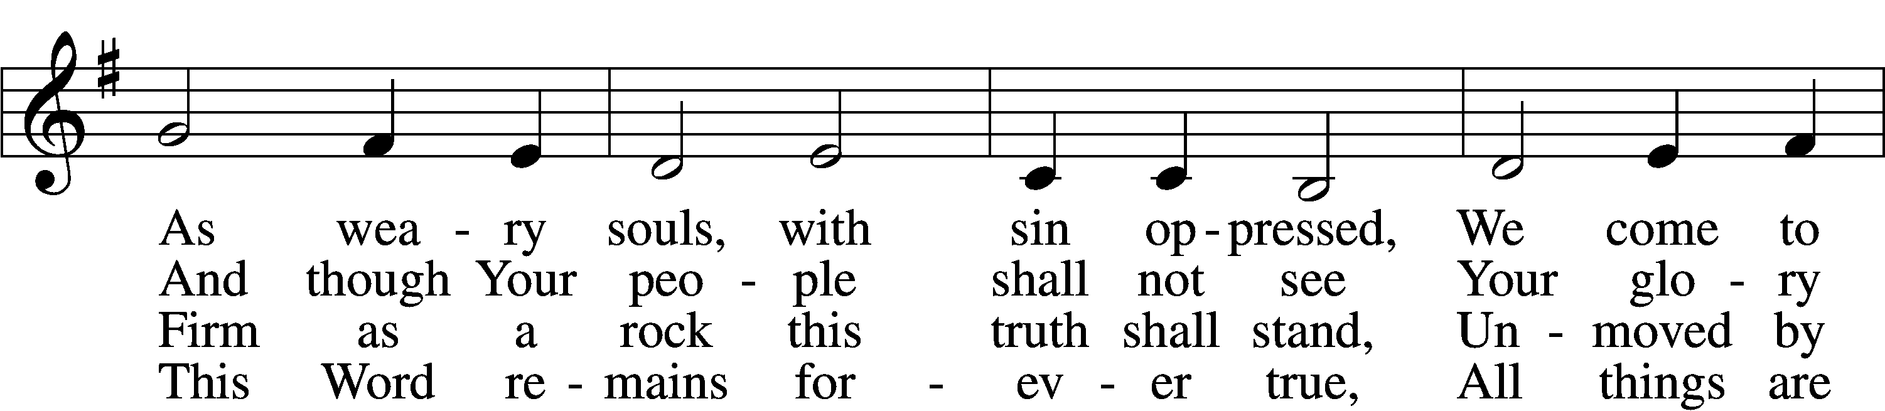
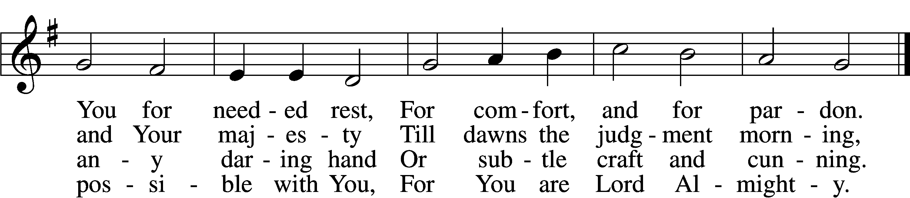

5 Though reason cannot understand,
Yet faith this truth embraces:
Your body, Lord, is even now
At once in many places.
I leave to You how this can be;
Your Word alone suffices me;
I trust its truth unfailing.

6 Lord, I believe what You have said;
Help me when doubts assail me.
Remember that I am but dust,
And let my faith not fail me.
Your supper in this vale of tears
Refreshes me and stills my fears
And is my priceless treasure.
Text: Samuel Kinner, 1603–68; tr. Emanuel Cronenwett, 1841–1931, alt. Tune: Peter Sohren, c. 1630–c. 1692, alt.
7 Grant that we worthily receive
Your supper, Lord, our Savior,
And, truly grieving for our sins,
May prove by our behavior
That we are thankful for Your grace
And day by day may run our race,
In holiness increasing.

8 For Your consoling supper, Lord,
Be praised throughout all ages!
Preserve it, for in ev’ry place
The world against it rages.
Grant that this sacrament may be
A blessèd comfort unto me
When living and when dying.

Please stand as able

THE DISMISSAL
P The body and blood of our Lord Jesus Christ strengthen and preserve you in body and soul
to life everlasting. Depart T in peace.
C Amen.

NUNC DIMITTIS LSB 211
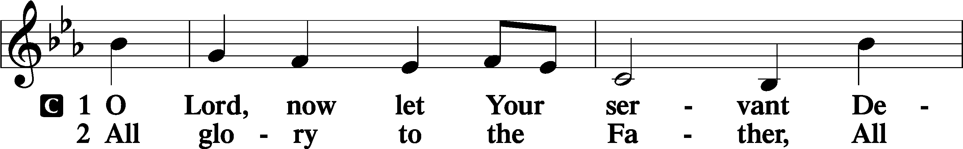
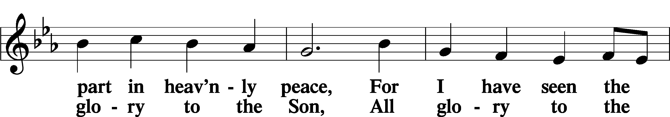
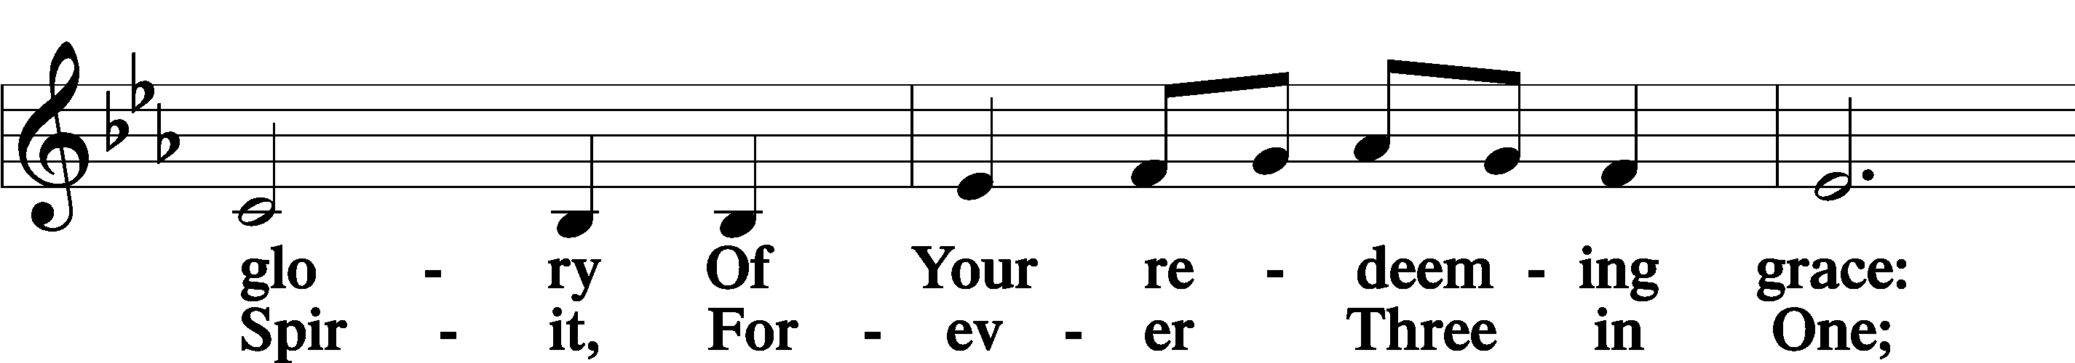
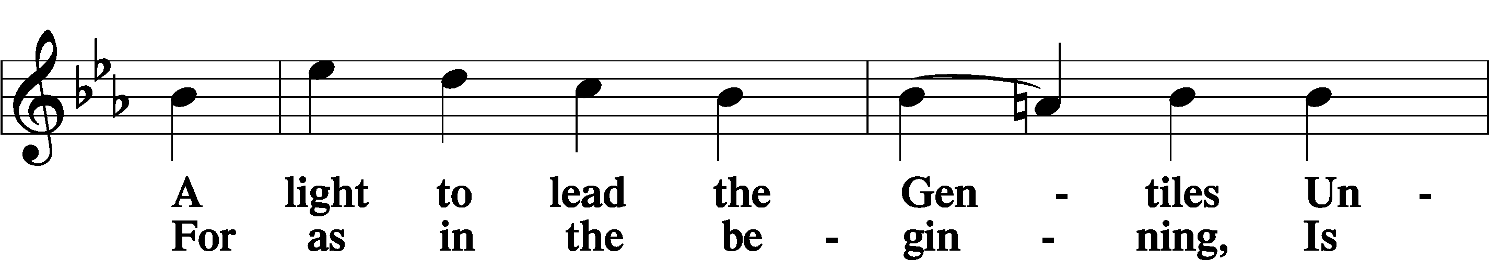
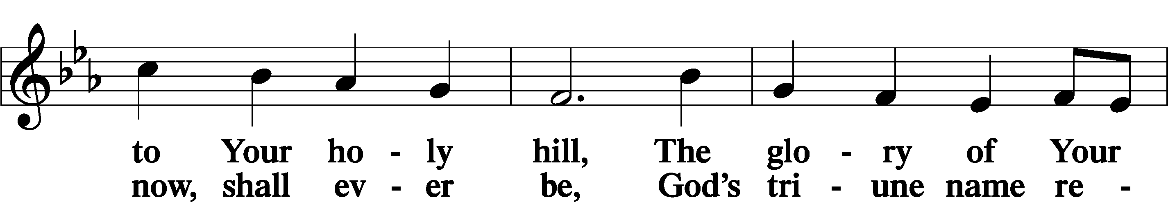
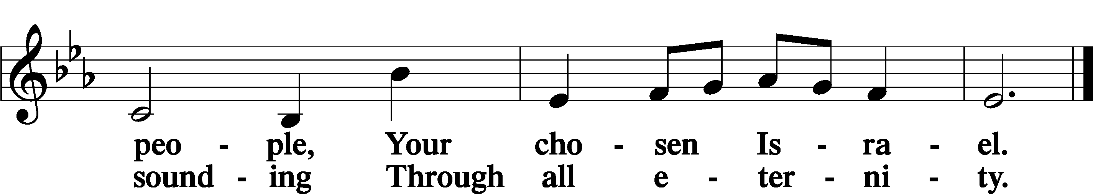

POST COMMUNION COLLECT
P Let us pray.
We give thanks to You, almighty God, that You have refreshed us through this salutary gift, and we implore You that of Your mercy You would strengthen us through the same in faith toward You and in fervent love toward one another; through Jesus Christ, Your Son, our Lord, who lives and reigns with You and the Holy Spirit, one God, now and forever.
C Amen.

BENEDICAMUS LSB 212
P Let us bless the Lord.
C Thanks be to God.
BENEDICTION
P The Lord bless you and keep you.
The Lord make His face shine on you and be gracious to you.
The Lord look upon you with favor and T give you peace.
C Amen.

Please be seated
CLOSING HYMN
Go, My Children, with My Blessing LSB 922 sts. 1–4
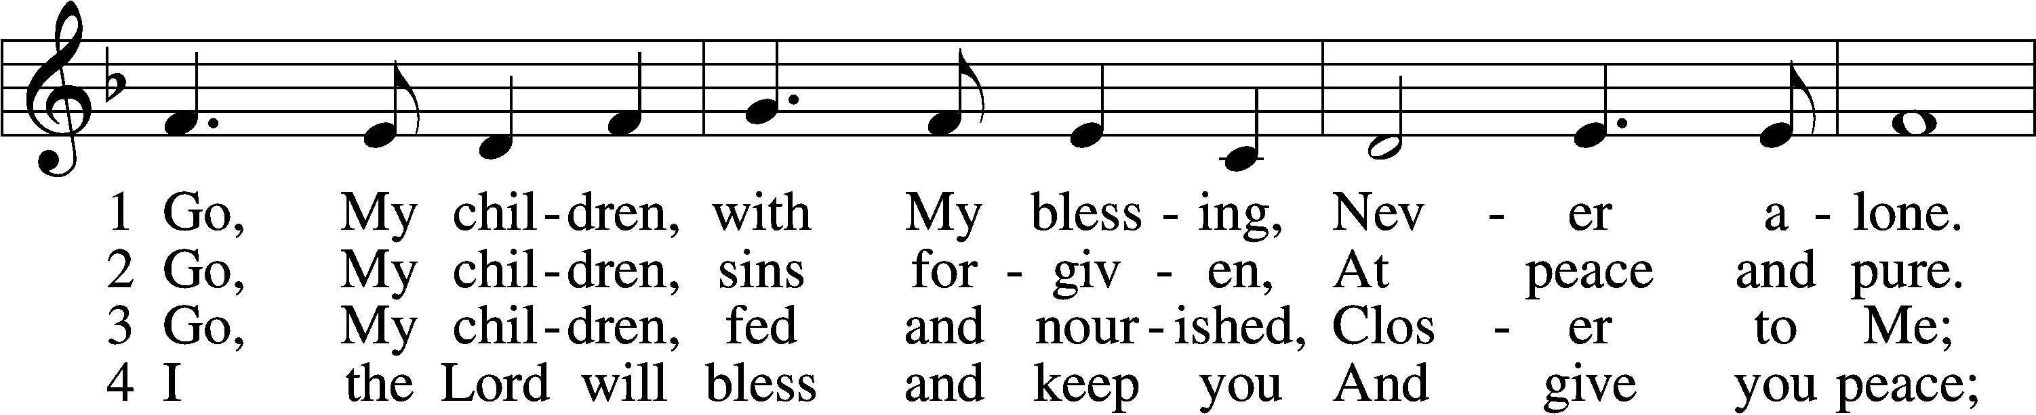
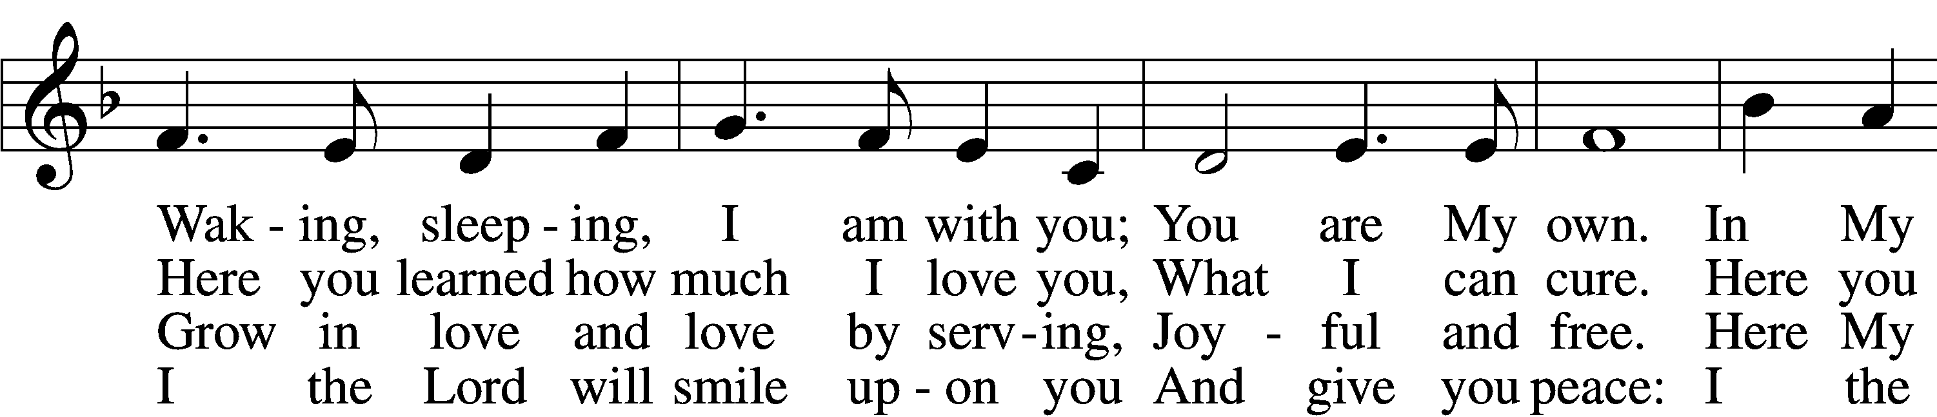
(Continued on next page)
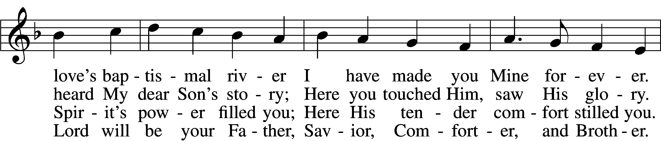
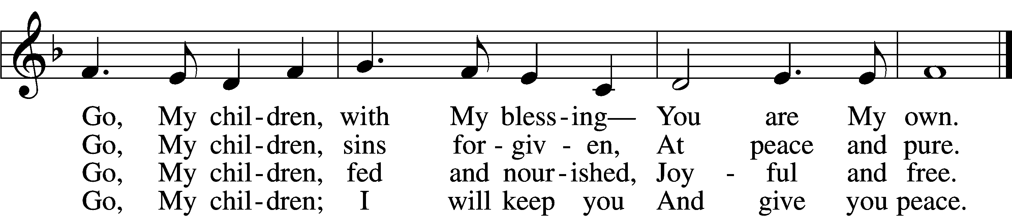
Text: Jaroslav J. Vajda, 1919–2008
Tune: Welsh, 18th cent.
Text: © 1983 Concordia Publishing House. Used by permission: LSB Hymn License no. 110002537
Tune: Public domain

ANNOUNCEMENTS and SENDING WORDS
P We go to live for Jesus!
C We go to share His love!

Acknowledgments
Unless otherwise indicated, Scripture quotations are from the ESV® Bible (The Holy Bible, English Standard Version®), copyright © 2001 by Crossway, a publishing ministry of Good News Publishers. Used by permission. All rights reserved. Created by Lutheran Service Builder© Concordia Publishing House.

SERVING in GODS HOUSE TODAY
Pastor: Rev. Ken Bernthal
Elder: Tim Arner
Ushers: Jim & Marge Kunisch
Greeters: Mike Goodrich, Bob Erat
Coffee: LWML
Counters: Donna Cottrell, Nancy Ely
Altar Care: Nancy Ely
Piano/Organ: Tom & Jean Beach
Children’s Talk: Nancy Ely

PRAYERS
Please contact the office with updates to the prayer list. People will remain on the prayer list for 4 weeks before being removed. If they need to remain on the list, please keep Elaine informed and of any updates. This will help us to have a more accurate list. Thanks for your cooperation.

Those who continue to grieve the passing of loved ones, Mazur family on the loss of their son.
Those with upcoming surgery: Ron Kwapis
Those recovering from surgery: Jennifer Martin
Those with health concerns: Tiffany Amsdill, Laurie Breen, Hope Buchinger, Karen Christoff, Kay Gregg, Hilda Koch, Brian Morgan, Eleanor Raether, Beth Smith, Judi Stutzman, and Joann Whitney.
Those diagnosed with cancer: Leah Eicher, Maria Freimark, Rachel Frisch, Joe Gibson, Janice Knoellinger, Leslie Martin, Hope Osantowski, and John Stutzman.
Those under Hospice Home Care: Ruth Luebs, and Ken Williamson.

BIRTHDAYS: ANNIVERSARIES;
4/17 Amelia Temple 4/12 Ken & Ann Mertz
4/17 Ron Tesolin

MESSAGES

MEMBER & GUEST CARDS: If you have not filled out a member/guest card, please take the time to fill one out and place it in the plate behind the back pews in our sanctuary.
WEDNESDAY MORNING BIBLE STUDY, 10:00am in the fellowship hall with Pastor Ken Bernthal.
GREETING CARDS If you are in need of some greeting cards, we carry an array of them in the cabinet in the library. The cost of the cards is posted on the cabinet. The money collected from the cards goes to LWML to help support Missions.
CANCER and FRIENDS SUPPORT GROUP: Will be meeting April 26th. We will be having a guest speaker from OCCOA. Please remember Cancer & Friends Support Group is not just for people going through treatment, or survivors, we are also here for caregiver, spouse, children, and friends. There are times when we can all use someone to talk to during those difficult times. If there is any subject you would like to discuss with me you call or text or at 989-350-4391. Hope you will join us.
CALLING ALL MITE BOXES. You know who you are. You have mite boxes stuck in your kitchen, in your laundry room, in your car... just waiting to get out and do good in the world. If you don't have a mite box, you have change, or maybe ones or fives or tens that could feed a hungry child, support a missionary or bring the gospel to people all over the world. The Michigan District of LWML is short about $37,000 to meet its mission goal for the 2020-2022 biennium, which ends April 30. You will see our BIG MITE BOX out every Sunday until then. We ask you to liberate your mite boxes and look deep in your hearts and pockets to help serve the Lord right from your seat in the pew. Or give to any LWML board member. You are thanked from all over the world.
KUT-UPS: Next meeting is Monday April 11th and 25th in the fellowship hall.

HELP FOR UKRAINE: Go online to www.lcms.org/Ukraine to get information on ways to help with support of displaced Ukrainians. Funds for Ukraine support can be channeled through LCMS, if you so desire. Gifts to the LCMS, including Mission Central, are restricted to providing aid and assistance to persons displaced by the war in Ukraine. The LCMS will issue grants to/through our Lutheran partners in the region best positioned to provide compassionate care in Christ’s name to those fleeing the conflict. The situation is developing, and LCMS pledges to use every gift wisely to accomplish the greatest good possible in ways that deliver the Gospel as human needs are met. (Our Church Council voted to send a donation from Trinity Lutheran Church.)

OTSEGO COUNTY FOOD PANTRY: If you would like to help at the Food Pantry on future dates for which Trinity is responsible for the manpower in distributing food to drive-up customers, there are sign-up sheets on our narthex bulletin board.

EASTER LILY-Please sign up to donate and Easter Lily for our Easter Celebration! The cost will be $10.00. Please Plan on picking your plant up after the Easter service. Make your check out to Trinity- Altar Care

CALL PROCESS: As you now know, Pastor Mayland has returned our call. We prayed for God’s will to be done and we must accept that it has. We now must restart the call process. Before the District will submit the request, they ask our congregations to submit the name(s) of any pastor who we would want to call. This doesn’t mean that the District would put them on our list, just that they would consider doing so. If you know of a pastor that you would like to include for consideration, there will be Nomination Forms available in the Church Office please fill out the form and return to the office. Deadline to submit the forms will be April 24th. Thank you.
Bob Erat
THIS WEEK AT TRINITY
April 10 Sunday Palm Sunday
9:00 am Worship Service - Holy Communion – Rev. Ken Bernthal
10:00 am Fellowship & Coffee Hour
10:30 am Sunday Morning Bible Study W/ Dr. Tom Beach

April 11 Monday
7:00 pm Choir

April 12 Tuesday
3:00 pm Heart of the Pines Quilt Guild – Fellowship Hall
6:30 pm Church Council Meeting
April 13 Wednesday
10:00 am Wednesday Morning Bible Study W/ Pastor Ken Bernthal

April 14 Thursday
7:00 pm Maundy Thursday Service - Rev. Ken Bernthal

April 15 Friday
7:00 pm Good Friday Service – Rev Paul Schneider

April 16 Saturday

April 17 Sunday Easter Sunday –
9:00 am Worship Service - Holy Communion – Rev. Paul Schneider
10:00 am Fellowship & Coffee Hour
10:30 am Bible Study with Dr. Tom Beach (Tutoring Room)

Easter Worship Schedule

Palm Sunday
Sunday, April 10, 9am service
Theme: The Stones Will Cry Out

Maundy Thursday
Thursday, April 14, 7pm service
Theme: Washing Feet

Good Friday
Friday, April 15, 7pm service
Theme: Individual People at the Cross

Easter
Sunday, April 17, 9am service
Theme:

